LPI Linux Essentials

The Linux Community and a Career in Open Source

Major Open Source Applications

Desktop Applications
Learn about a few desktop-based applications available for Linux and some of the desktop environments available.

Server Applications
A server is a powerful computer that serves data from itself to client systems
A web server sends web pages to a user’s application, such as a Firefox web browser on a desktop
Common Network Ports
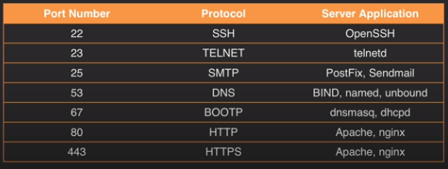

Development Languages
Open source development relies on a number of programming languages; this lesson provides an overview of languages commonly used in Linux development and the differences in their execution.

Compiled Languages:
- C
- C++
Interpreted Languages:
- Python
- PHP
- Java
- Perl
Assembly Languages

Package Management Tools and Repositories
Learn about the various ways you can install programs with package management tools and repositories.
What is Package Management?
A method for installing software on a Linux system
What Constitutes a Package?
Dependency information
Version information
Architecture information

Two Methods for installing software:
.Installing from source (en téléchargent le .tar puis en le compilant)
.Pre-built Packages:
- RPM ( Red Hat Package Manager)
- .deb (Debian)

YUM Package Management
YUM works with the repositories to install, remove, and update software on Red Hat based systems.
YUM commands:

yum search httpd
yum install httpd
yum deplist httpd ( for see what dependencies are needed)
yum list installed httpd
yum update
yum remove httpd

For check if a software is installed like httpd : which httpd
To find out what repositories we’re getting our packages from: yum repolist
Les dépôts sont dans le fichier /etc/yum.repos.d
How to clean the local yum database of packages: yum clean all

RPM Package Management
This is a walkthrough of using RPM to install, remove, and update software on Red Hat based systems.
RPM is the original command but rpm don’t install dependencies.
Rpm is use for installations of single files
We use this command like this: rpm –ivh NameOfThePackage.rpm
-I for install an rpm file
-v shows us what the command is doing
-h gives us a progress bar
-e = erases an rpm file
-q = queries an rpm file
-U = updates an rpm file

ATP Package Management
Learn how to work with packages on a Debian-based system using APT.
Les dépôts sont dans le fichier /etc/apt/sources.list

"apt install" install a package from a repository.
"apt remove" uninstall a package.
"apt update" downloads available package information from your repos.
“apt upgrade” upgrades packages listed in your repos. It resolves dependencies, but doesn’t remove existing packages.
“apt full-upgrade” does the same as “apt upgrade”, but it will remove a package if that action is needed to update the system.
"apt-cache search PackageName" queries the local apt cache for a package.
"apt remove --purge PackageName" grand nettoyage des paquets supprimés.
For check if a software is installed like httpd : which httpd

dpkg Package Management
Learn how to manage software on a Debian based system with dpkg.
dpkg-deb –I = queries a .deb package
dpkg-deb –contents Package = voir ce que contient un package

dpkg-deb –I = list all packages installed

dpkg -i Package = Install a package

dpkg -r Package = Remove a package

dpkg -l Package = queries a .deb package

Understanding Open Source Software and Licensing

Software Licensing
We review software uses licensing to determine how it is used, altered and distributed; learn the limitations and benefits of various software licenses.
In USA, all software is copyright protected, excluding software in the Public Domain
Berne convention extends the protection of copyright law to other nations
Open Source Software licensing uses documents to alter the terms with which software is released:
- The source code is distributed with the software.
- End users have the right to modify and redistribute the softwares.

Free Software Foundation and the GPL
The Free Software Foundation has been around for quite a while. It was founded by Richard Stallman in 1985.
The FSF is the primary supporter of the GNU Project. Free software is software that we could have full control
over and that is not directed by any corporation or government entity. This means that along with the
software, we would have the source code and the ability to do whatever we wish with it.

The Free Software Foundation defines itself by these four software freedoms:

You are free to use a software for any purpose
You have the ability to examine the source code and modify it as you see fit.
You are free to give a copy of the software
You are free to give a copy of your software modified.
Free software does not necessarily mean price. This does not mean that you can not purchase
free software. If someone wrote an application that is free software and you purchase a copy of it, you should
also have access to the source code for that application.
One of the tenants of the GPL is that any software created with GPL software, such as any derivative works must also be released under the GPL.

Creative Commons
Les Creative Commons, qu’est-ce que c’est?
Creative Commons est une organisation non gouvernementale à but non lucratif qui propose des licences (licences CC) permettant aux auteurs de mettre leurs oeuvres à disposition du public selon des conditions prédéfinies. Ces licences s’articulent autour des quatre options suivantes :
Attribution : cela signifie que ceux qui utilisent votre oeuvre peuvent la reproduire, la distribuer et la communiquer librement, à condition qu’ils vous en attribuent expressément la paternité. Cette condition est commune à toutes les licences CC.
Pas d’utilisation commerciale : vous autorisez ceux qui utilisent votre oeuvre à la reproduire, à la diffuser ou à la modifier, mais uniquement dans un but non commercial Si un utilisateur souhaite utiliser votre oeuvre à des fins commerciales, il devra obtenir votre autorisation.
Partage dans les mêmes conditions : Votre oeuvre peut être reproduite et modifiée pour créer des oeuvres dérivées mais celles-ci devront être publiées sous les mêmes conditions que votre oeuvre original. Toute personne souhaitant publier une adaptation sous d’autres conditions doit obtenir votre autorisation préalable.
Pas de modification : vous autorisez la reproduction et la diffusion uniquement de l’original de votre oeuvre, sans modification. Votre accord est nécessaire à toute traduction, altération, transformation ou ré-utilisation dans une autre œuvre.
Ces options sont combinées différemment au sein de 6 licences principales.
Du fait de leur succès, de nombreuses plateformes intègrent la publication d’oeuvres sous Creative Commons, dont notamment :
- Wikipédia (80 % étant sous licence CC) ;
- 500px, Flickr ou encore Unsplash pour les photographies
- Vimeo ou encore Youtube (qui répertorient, ensemble, près de 35 millions de vidéos sous licence CC dont de nombreuses oeuvres musicales).
Au total, plus de 1,2 milliard d’oeuvres dans le monde sont diffusées sous licence Creative Commons.
Quelle est la valeur juridique des licences Creative Commons?
Rédigée par des experts en droit d’auteur, les licences Creative Commons sont en réalité des contrats-type qui facilitent la libre circulation des oeuvres sur Internet tout en garantissant la protection des droits des auteurs. Si votre oeuvre n’est pas utilisée conformément à la licence choisie, vous pourrez agir en justice contre l’utilisateur qui n’en respecte pas les termes. Puisqu’elles reposent sur une logique contractuelle, les licences Creative Commons ont été validées par les tribunaux, que ce soit en Espagne, en Allemagne et même dans les pays de Copyright tels que les Etats-Unis.
S’il n’existe pas de jurisprudence spécifique aux licences Creative Commons en France leur validité n’est pas remise en cause. D’une part, avec une licence Creative Commons, l’auteur ne cède pas ses droits d’auteur mais précise simplement la manière dont il souhaite les exercer.

Open Source Business Models

One question that often gets asked within the Linux World is how do you make money on something that has given away for free?

One way is via donations. The Free Software Foundation rely on donations. Debian, one of the first distributions
of Linux, is also supported by donations.
Bug Bounties are another way to make money within the open source community. A developer who is really good at hunting down issues that have plagued someone for a while can make some cash by routing out these issues in fixing them.
The developer can be sponsored from a bug bounty, which is a price that is set on a particular bugs fix.

ICT Skills and Working in Linux

Desktop Skills
Wide variety of desktop environments
Office productivity suites → LibreOffice
Web browsers → Firefox, Chrome, Opera, etc.
Email applications → Thunderbird
File saving
Terminal applications

Popular Desktop Environments:
- Gnome
- KDE
- XFCE

Hands-On: Desktop Skills

Getting to the Command Line
Ctrl + Alt + F pour ouvrir différents terminaux

Industry uses of Linux, Cloud Computing, Virtualization
Linux can be found everywhere
Web Servers
- Over 66% of the internet is on Linux
- Apache and Nginx

Supercomputers
- CERN runs Scientific Linux and CentOs
- IBM iDataPlex

SQL Database Servers
- Oracle

Cloud Computing
- Google Applications
- Dropbox
- Amazon Web Services
- Evernote
- Docker
- OpenShift

Virtualization
Virtualization contains two main components:
- Hypervisor
- Guest

Popular Virtualization Software (Hypervisor):
- VMWare
- KVM/QEMU
- XEN
- VirtualBox

Finding your way on a Linux System

Command Line Basics

Command ls
List the content of a directory
For see hidden files: ls –a
For show file and directory ownership, permissions and sizes: ls -l
For show files sort by size with the largest at the top: ls-s

For show files sort by last time modified: ls -t
On peut lister un dossier sans y entrer: ls -l NomDuDossier, ex: ls -l Documents
List directories recursively: ls -R

Command Line Syntax -$PATH and Case Sensitivity

In order to execute a command that you type at the command prompt, it needs to know where that command is.
We can see all environment variables with the command env
The path environment, variable the path environment variable. List out all of the directory locations that bash will look in whenever we type a command at the prompt.

For see the contents of the Path environment variable we tape: echo $PATH
Pour être exécutée de n’importe où en relatif, une commande doit être dans un des dossiers de la variable PATH.

Command Line Syntax - Basic Commands
Display your currently logged in user - whoami
On peut aussi faire echo $LOGNAME
Change user – su NameUser
To log as the root user : su -
Leave a shell environment – exit
Poweroff, reboot or stop: shutdown
Interactively display top running processes on a system: top

Command Line Syntax – uname
Display the name of the system kernel : uname

Display all information that uname can show: uname -a

Command Line Syntax – cd and pwd
Print the current directory that you are in: pwd
Change directory: cd
With no path you will change back to the home directory
Go up one directory: cd ..

Command Line Syntax - Basic Command History and Command Completion

bash_history: Is a hidden file that contains a log of all commands entered at the Bash prompt
Au lieu d’ouvrir ce fichier tu peux juste taper la commande history
Pour voir un fichier sans l’ouvrir on utilise la commande cat + NomDuFichier

HISTFILESIZE : Environment variable that specifies how many lines of history to keep

Pour la voir tu tapes: echo HISTFILESIZE
Dans un environement très securisé la valeur mise pourrait être de 0 afin de ne rien retenir.

Shell Configuration Files
Learn about the various files that set up a Bash shell environment.

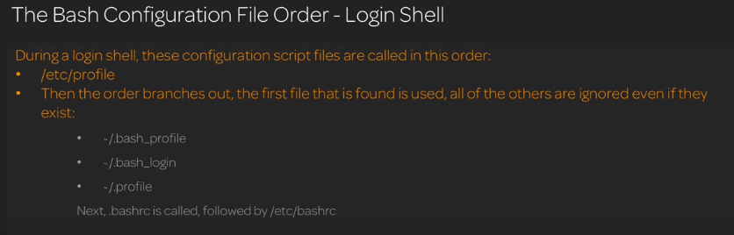
cat /etc/profile

Shell Variables
Learn about what a variable is and how to use environment-defined variables on the command line.
env : lists out environment variables of the currently logged in shell
echo $VARIABLE prints the value of VARIABLE to the screen
set – lists out all environment variables in alphabetic order
Pour declarer une variable: VARIABLENAME=value
Si tu veux ajouter un dossier à la variable PATH, par exemple opt, tu tapes ceci: PATH=$PATH:/opt

Globbing

Use globbing to effectively search and expand files and text in Linux.
Chercher tous les fichiers en .txt : ls *.txt
Chercher tous les fichiers commençant par ab: ls ab*
Chercher les fichiers commençant par un p ou P: [pP]*.txt

Quotting



With single quotes :

Formatting Commands
Command
Command + options
Command + options + arguments



Locate, Find and Whereis
Learn about these three helpful utilities that can assist you in finding files and folders within Linux.
Locate: searches a local database of files and folders looking for items that match the search criteria, ex: locate cd

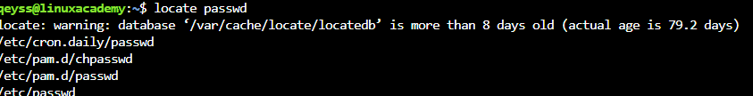

Find: searches the file system for files that match the search criteria:
find /path/to/folder –name file, ex: find /home/qeyss –name ‘*.txt’
find is a bit slower than locate, but you can get more accurate results with the find command.
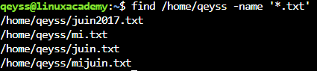

Whereis: locates binary source and/or manual pages for a command

Using the Command Line to Get Help

Man
Manual pages command, invoked by entering man + command, ex: man ls

Whatis
Command that lists summaries and related man pages based on search term, ex: whatis passwd

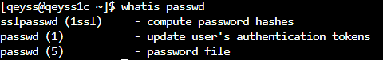

Apropos
Command that searches man pages for appearances of the keyword provided, invoked by entering apropos + keyword

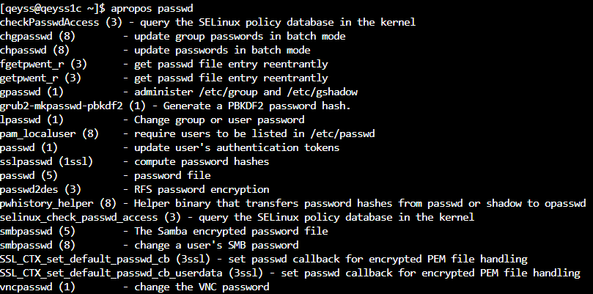

Info

Un peu similaire à la commande man – info + commande, ex: info cp

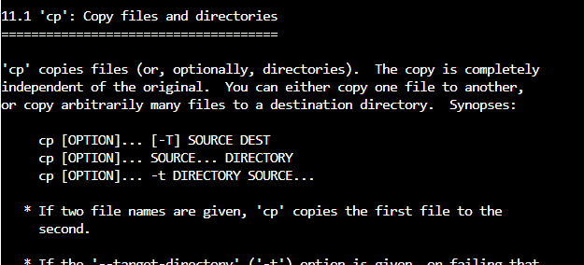

More Local Documentation
There are local documents in :
/usr/doc/packagename
/usr/share/doc/packagename
/usr/share/doc/packages/packagename

Using Directories and Listing Files

The Linux File System

Case sensitive
Paths are delimited by a /
Any folder or file whose name is preceded by a .(dot) are hidden from normal view

Absolute and Relative Paths

cd + ENTER → Return to the home directory
cd .. → The double dot reference points to the directory above us
cd ~ ( wildcard) → Return to the home directory

An absolute path is a complete path from start of actual filesystem from / directory or we can say from the root directory(/)

Relative path is defined as path related to the present working directory
Suppose I am located in /var/log and I want to change directory to /var/log/kernel. I can use relative path concept to change directory to kernel by using relative path concept: cd kernel
The absolute path will be: cd /var/log/kernel

Creating, Moving and Deleting Files

Files and Directories
Learn how to create files and directories, and the various commands used to manipulate them.
mkdir – make a new directory
mkdir - p → make a new directory with a sub directory → mkdir - p project/task1
touch – create en empty file
rmdir – remove an empty directory
cp – copy a file or folder → cp <file name> <destination>
cp - R : copy a folder recursively
cp - V : display what the copy command is doing

mv - move or rename a file or folder → mv <file name> <destination> and → mv <old name> <new name>
rm - remove a file
rm - r: recursively remove a folder and its contents.
rm – r *: remove all files of a directory

The Power of the Command Line

Archives and Compression

Learn how to create archives with tar, and compress files and directories with gzip, bzip2, and zip.
tar – manipulate archive files
-c = create a new archive
-z = pass the archive through gzip compression
-j = pass the archive through bzip2 compression
-f = file name of archive to create
-x = extract an archive
-v = verbose output

zip – create a new compressed file
-r = recursively create a compressed file directory and its contents
unzip – extract a zip archive
gzip – create a gzip archive
gunzip – extract a gzip archive
bzip2 – create a bzip2 archive
bunzip2 – extract a bzip2 archive
Syntaxe : tar -cf <new archive name.tar> <file to archive>
Exemple avec le dossier IT : tar -cf IT.tar IT
Tu auras ensuite un dossier intitule IT.tar
Pour visualiser le contenu de l’archive sans l’ouvrir on tapera : tar -tf IT.tar
Pour extraire l’archive on tape : tar -xf IT.tar
Jusque-là on a créé une archive sans la compresser.
Créer et compresser une archive avec gzip : tar -czf IT.tar.gz IT
Créer et compresser une archive avec bzip2 : tar -cjf IT.tar.bz2 IT
Décompresser une archive créée avec gzip : tar -xzf IT.tar.gz
Décompresser une archive créée avec bzip2 : tar -xjf IT.tar.gbz2
Si tu veux voir en même temps les étapes d’extraction tu ajoutes un v à xjf par exemple.
Créer une archive compressée avec la commande ZIP
Syntaxe : zip -r <new archive name.zip> <file to archive and compress>
zip -r IT.zip IT
Pour décompresser un zip on utilise la commande unzip:, ex: unzip IT.zip
Créer une archive compressée avec la commande gzip
gzip <file to archive and compress>
Pour décompresser: gunzip <file to decompress>
Créer une archive compressée avec la commande bzip2
Bzip2 <file to archive and compress>
Pour décompresser: bunzip2 <file to decompress>

Searching and Extracting Data from Files

Viewing Text
1

Analyzing Text
1

Pipes and Regular Expressions
1

Turning Commands into a Script

Nano
1

Vi/Vim
1

Your computer on the Network

Basic Networking

IP address
Each computer connected to a network has an IP address. This IP address can be compared
to a phone number, a string of digits that allows one machine to contact another. This is the numerical address that identifies your computer on a network. The letters IP are an abbreviation for Internet Protocol.
Subnet mask
The next component is the subnet mask, also known as the network mask or netmask. This address
provides a more accurate description of the network the computer is attached to.

Gateway
Now if this device wanted to communicate with another network it will need a gateway to talk to. The gateway address is the same as the IP address of a device on the network. That device, usually
being a router, is responsible for communications between hosts of other networks. You will also need a way to translate website names to an IP address.

DNS
When you type in a Web address such as linuxacademy.com your computer needs to find out where that server is located in order to find the Web page, so your system will need to translate this domain name of linuxacademy.com to its IP address. This is done with the help of DNS, or domain name services.
These are large systems on the Internet that contain a database of sorts that has a listing of domain names
and their associated IP addresses. In keeping with our telephone analogy, you can liken this to looking
up someone's name in the phone book to find their phone numbers so that you can call them. Once all of these pieces are in place, our system can connect to another network such as the Internet.

How to reach a website
First, the computer needs to find out what IP address houses the website that they wish to access,
so they will ask DNS to find this out for them. Once they get the IP address of where they want to go, the
computer sends its request for the website out of the subnet. The traffic encounters a door to the room,
which is the network gateway, and asks the gateway where it needs to go to find this website. The gateway then adds information to the data requests, such as a map through the hallway that should route it to the appropriate room that has the website.
The website responds to the original request, sending the response back to the original requesting computer via the routing information found in the original request.
This is quite an oversimplification of how networks function.
Every computer that is using IP addresses to communicate with other systems has an
IP address assigned to them. We said before that this IP address identifies the system on the network.
There are two other addresses that a network computer has. The first is the loopback or local address. Each computer has the same IP address of 127.0.0.1. This address is not accessible from other machines. It is mainly meant to be used on a per machine basis to test to see if the IP protocols are working on the system. The other address is the Mac address. The Mac address is the actual hardware address that is burned into the network interface adapter. Each and every network interface adapter has one, and they're created by the device manufacturer.
These are designed to uniquely identify each piece of hardware on any network.
Let's take a look at routers.
We talked about the gateway device on a network that routes data traffic from one location to another. These devices, called routers, keep their own listing of IP addresses of where they should send data. For example, when you're at home and you're on your computer that's connected to the Internet, you are using a router that communicates with your Internet service provider. Oftentimes they will look
like this. This device takes the traffic that is bound for the Internet and routes it to your Internet service provider.
Your service provider will then check their collection of routes known as the routing table, to send your data request on their way. The service provider keeps track of so many routing tables that they use stacks of routers that often look like this. Router systems such as these are what keep the Internet connected.

Networking in Linux
Learn about some of the command line tools used to query information about your network settings.

To install DNS utilities on Ubuntu, use:
# apt-get update
# apt-get install dnsutils -y
For CentOS, use:
# yum install bind-utils

View your IP address configuration:
ifconfig
ip addr show
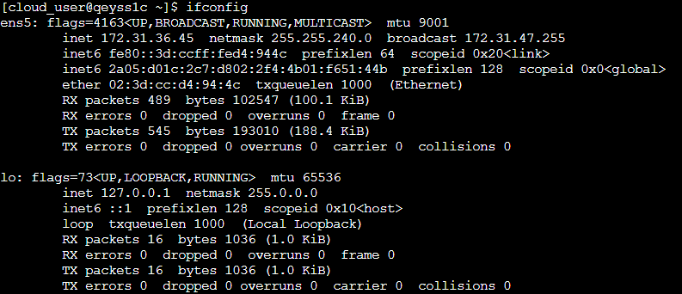
Les adresses Ip privées des différentes classes :
Les adresses privées de la classe A : 10.0.0.0 à 10.255.255.255.
Les adresses privées de la classe B : 172.16.0.0 à 172.31.255.255.
Les adresses privées de la classe C : 192.168.1.0 à 192.168.255.255

View your default gateway
When we need to contact systems outside of our network we need to know the gateway Ip address. This device is what will routes are outbound traffic to these other networks. We could check our default gateway that our system contacts with the ip route show Command. This output shows us that by default, all of our outbound traffic is routed to the gateway at 172.31.16.1 and through our eth0 interface.

The older method of viewing your default route is by using the route command.
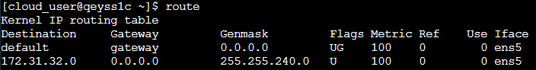
On peut aussi utiliser la commande : netstat -r
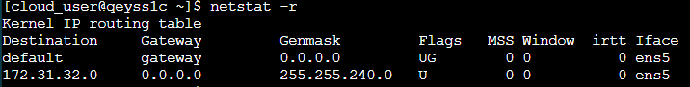

DNS servers
La liste est dans /etc/resolv.conf
We can test DNS name resolution without accessing a website by using the host command like:
Host domain name → host google.fr
Test the network connectivity with the command ping
Ping is one of the most useful tools when trouble shooting a network connection. If you are unsure of your network
connection, just ping either an IP address or a host name of a system to see if you get a response.
Exemple: ping –c 3 google.com
The -c 3 switch sends three data packets

Another location that can house name resolution settings for us is in the local etc Host file. /etc/hosts
If you notice here we have the local loopback IP address of 127.0.0.1 and below it is the IPv6 version of the loopback
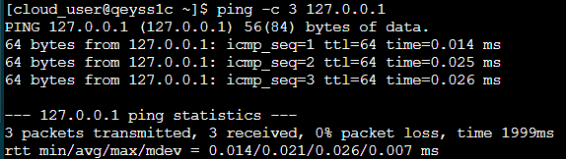

Quiz: The Linux Community and a Career in Open Source

Question 1 of 23
Select possible package management command line tools: (Choose all that apply)

Choose the 3 correct answers:
Top of Form
 apt
GET
dpkg
yum
Bottom of Form

Question 2 of 23
Which are open source office application suites? (Choose all that apply)

Choose the 2 correct answers:
Top of Form
Libre Office
OpenOffice
Microsoft Office
Lotus Notes
Bottom of Form

Question 3 of 23
The following are examples of systems that can often or always use Linux based software: (Choose all that apply)

Choose the 2 correct answers:
Top of Form
GPS Device
Windows Phone
Apple iPhone
Android Phone
Bottom of Form
Question 4 of 23
Which of the following is a widely-used open source server application that runs many of the world's websites?

Choose the correct answer:
Top of Form
Postfix
IIS
Apache
OpenSSH
Bottom of Form

Question 5 of 23
Which operating system is a Linux distribution?

Choose the correct answer:
Top of Form
FreeBSD
Red Hat Enterprise Linux
MS Windows Server 2016
Novell
Bottom of Form

Question 6 of 23
What is an open source alternative to Adobe Photoshop?

Choose the correct answer:
Top of Form
Publisher
GIMP
MS Paint
Corel Draw
Bottom of Form
Question 7 of 23
Operating systems have been around for a quite a while. What are some possible operating systems other than Linux? (Choose all that apply)

Choose the 3 correct answers:
Top of Form
Microsoft Windows
AWS
macOS
DOS
Bottom of Form

Question 8 of 23
The following items are what usually make up a full-blown Linux distribution: Core Unix tools, supplemental software, installers, startup scripts or services, and ________.

Choose the correct answer:
Top of Form
the Linux kernel
cool logos
names
penguin mascots
Bottom of Form

Question 9 of 23
The GNU Project states that contributors can assign the copyright for GNU packages; this will allow them to be free through the Free Software Foundation (FSF).

Choose the correct answer:
Top of Form
Maybe
True
Not Sure
False
Bottom of Form

Question 10 of 23
You can download the source code for the latest release of the Linux kernel and modify it and create your very own Linux Distro.

Choose the correct answer:
Top of Form
Maybe
False
Not Sure
True
Bottom of Form

Question 11 of 23
Who is the FSF?

Choose the correct answer:
Top of Form
Free Software Foundation
Freedom Software Foundation
Fedora Software Foundation
Friendly Software Foundation
Bottom of Form

Question 12 of 23
What is the philosophy behind making applications free to download and use?

Choose the correct answer:
Top of Form
Open source
Unix
MS Licensing
Closed source
Bottom of Form

Question 13 of 23
It is required that the application's ____________ must be made available when released under the GNU GPL (General Public License).

Choose the correct answer:
Top of Form
download link location
source code
software author
links to similar apps
Bottom of Form

Question 14 of 23
What operating system inspired Linus Torvalds to create his own open source operating system?

Choose the correct answer:
Top of Form
UNIX
DOS
MINIX
Novell
Bottom of Form

Question 15 of 23
Select all possible Linux desktop environments: (Choose all that apply)

Choose the 2 correct answers:
Top of Form
GNOME
KVM
Explorer
KDE
Bottom of Form

Question 16 of 23
Who developed the first Linux kernel?

Choose the correct answer:
Top of Form
Bill Gates
Steve Jobs
Dr. Andrew Tanenbaum
Linus Torvalds
Bottom of Form

Question 17 of 23
Anyone can legally create their own Linux distributions.

Choose the correct answer:
Top of Form
True
False
Maybe
Not Sure
Bottom of Form

Question 18 of 23
The following are the two primary development models found in the open source development world: (Choose all that apply)

Choose the 2 correct answers:
Top of Form
GNU General Public License
Open Source Model
Bazaar Model
Cathedral Model
Bottom of Form

Question 19 of 23
Which of the following are possible development languages that you might find within a Linux development machine? (Choose all that apply)

Choose the 3 correct answers:
Top of Form
C
Python
PHP
Crudini
Bottom of Form

Question 20 of 23
What is a widely-used open source database server that is used by many organizations today?

Choose the correct answer:
Top of Form
Excel
MySQL
MS SQL
Oracle
Bottom of Form

Question 21 of 23
Who created the operating system that inspired the creation of Linux?

Choose the correct answer:
Top of Form
Linus Torvalds
Dr. Andrew Tanenbaum
Bill Gates
Steve Jobs
Bottom of Form

Question 22 of 23
GNU is an acronym that stands for what?

Choose the correct answer:
Top of Form
Getting Nice Users
Gnome
Good Network Unix
Gnu's Not Unix!
Bottom of Form

Question 23 of 23
What is a versatile web server available for Linux, besides Apache, that has built-in load balancing options?

Choose the correct answer:
Top of Form
nginx
Radware
IIS
F5
Bottom of Form

Answers

9) The GNU Project states that contributors can assign the copyright for GNU packages; this will allow them to be free through the Free Software Foundation (FSF).
Incorrect

Correct answer
True

Explanation
This is part of the GPL preamble.

Further Reading
https://linuxacademy.com/cp/courses/lesson/course/1572/lesson/1/module/161

16) Who developed the first Linux kernel?
Incorrect

Correct answer
Linus Torvalds

Explanation
Linux Torvalds developed the Linux kernel.

Further Reading
https://linuxacademy.com/cp/courses/lesson/course/1563/lesson/1/module/161

20) What is a widely-used open source database server that is used by many organizations today?
Incorrect

Correct answer
MySQL

Explanation
All other database systems listed are proprietary, except for Excel, which is a spreadsheet application.

Further Reading
https://linuxacademy.com/cp/courses/lesson/course/1561/lesson/2/module/161

1

